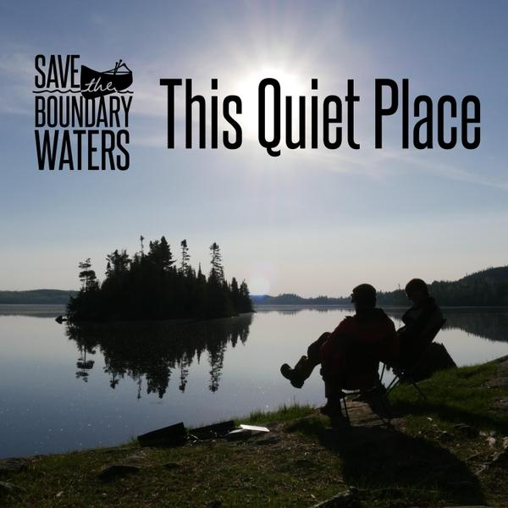

|  |
| --- |
|  |
| BACKGROUND |
| This campaign was organized by residents in Ely, Minnesota. This dedicated group is spreading awareness and preventing a copper-sulfide ore mine from being proposed alongside the Wilderness Area boundaries. The organization has since spread nationwide, gaining followership in an effort to save America’s most visited Wilderness area from the nation’s most toxic industry. |

|  |
| --- |
|  |
| GET INVOLVED |
| **Donate**: Help Save the Boundary Waters reach our Give to the Max Day goal of $150,000 by making a gift today!  **Sign the Petition**: Tell congress to defend the Boundary Waters.  **Attend & Host Events**: House parties allow for meaningful conversations and community building.  **Volunteer**: Focused on education, advocacy, outreach, and of course a love of the Boundary Waters, teams are made up of dedicated, and fun-loving volunteers that are passionately fighting to protect our favorite Wilderness. |

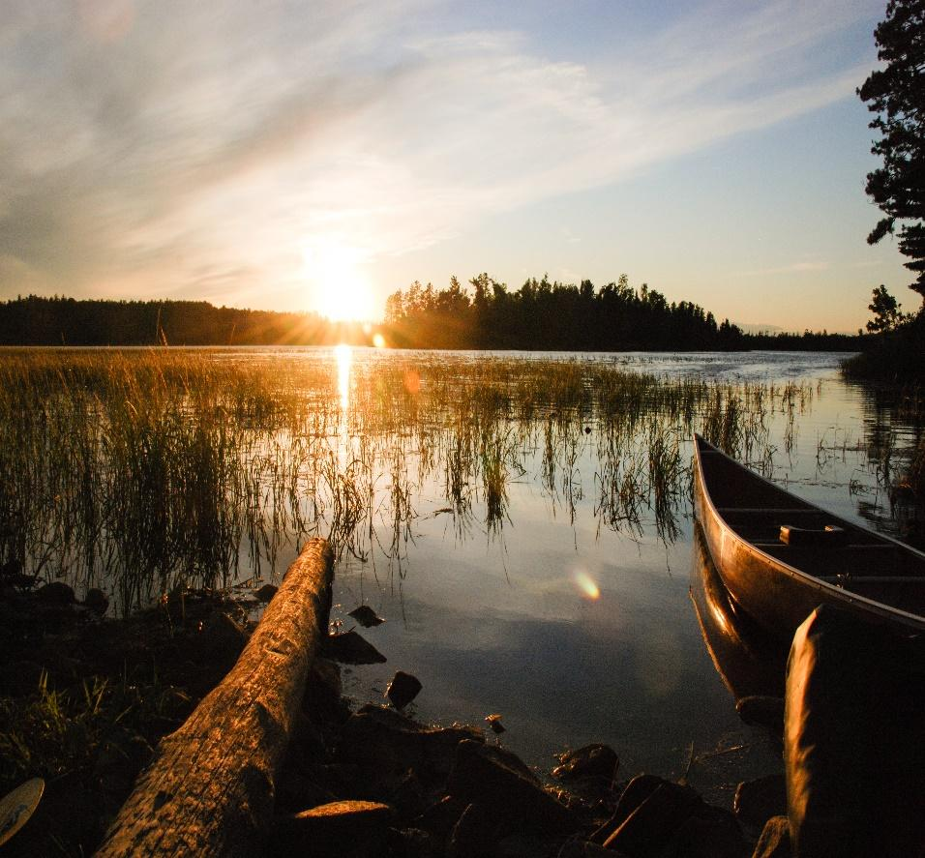

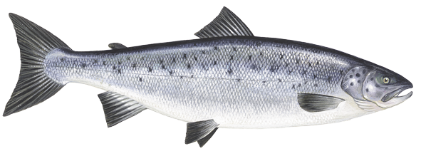

|  |
| --- |
|  |
| RAISING AWARENESS |
| Recently, we have introduced House Bill 5598; The Boundary Waters Wilderness Protection and Pollution Protection Act. Introduced by Betty McCollum back in January of 2020, this bill would establish roughly 234,328 acres as federally protected land. This would prohibit any mining operation from damaging the wilderness area.  **Check out our website** **@**: [www.savetheboundarywaters.org](http://www.savetheboundarywaters.org)   * Make Donations * Member Sign-Up * Event Information   ***With your help, we can save our beloved wilderness from irreversible damage.***  **Join the fight today!** |

**Campaign to Save the Boundary Waters**



|  |  |
| --- | --- |
|  | |
| CONTACT US | |
| **Northeastern Minnesotans for Wilderness (NMW)\*** *P.O. Box 625 Ely, MN 55731 218-365-7808* | |
|  | facebook.com/savethebwca |
|  | twitter.com/savethebwca |
|  | instagram.com/savethebwca |
|  | vimeo.com/savethebwca |
| **General inquiries:**  [info@savetheboundarywaters.org](mailto:info@savetheboundarywaters.org) | |
| **You can update your contact information or recurring gifts on our supporter portal page.** | |
| **\*NMW is the fiscal sponsor for Campaign to Save the Boundary Waters and Sustainable Ely** | |

|  |
| --- |
|  |
| RESOURCES |
| McCollum, Betty. “H.R.5598 - Boundary Waters Wilderness Protection and Pollution Prevention Act.” *CONGRESS.GOV*, 30 October 2020, https://www.congress.gov/bill/116th-congress/house-bill/5598. Accessed 30 September 2020.  Save Boundary Waters. “The Campaign to Save The Boundary Waters.” 2020, www.savetheboundarywaters.org/. Accessed 13 10 2020.  Icons made by https://www.flaticon.com/ |